SIMATS ENGINEERING (SAVEETHA SCHOOL OF ENGINEERING) Department of Computer Science and Engineering
ASSESSMENT TOOL 2 – CASE STUDY
Course Code: | CSA06 | Course Title: | Design and Analysis of Algorithms
CO Assessed: | CO3: Articulation (BL4, BL5) | Assessment: | Assessment Tool 2 – Case Study
Weightage: | 20% of CIA | Total Marks: | 100
CO3 Statement: | Design Divide and Conquer algorithms for Merge Sort, Quick Sort, Binary Search and Matrix Multiplication
Student Name: | KAILASH M | Reg. No.: | 192524029
Section / Batch: | 2025 | Date: | 06/08/2026

Instructions to Students
• Answer the following question. Total Marks: 100.
• Carefully analyze the given case study questions.
• Explain in detail with sample code if needed.
• Clearly identify all key issues, provide an in-depth analysis, and propose innovative, feasible solutions with strong justification.

Question Type | Focus Area | Questions
Case Study | Focus on Design Divide and Conquer algorithms: Merge Sort, Quick Sort, Binary Search and Matrix Multiplication | Q1

SECTION A – CASE STUDY
Code of Conduct
I KAILASH M (192524029) certify that this submission is my original work and that I have adhered to the guidelines specified for this assessment. I understand that any violation of academic integrity rules will result in disciplinary action.
Signature of the Student: KAILASH M

Online Advertisement Ranking using Quick Sort

Problem Understanding
An advertisement platform needs to rank advertisements according to their relevance and bid value. Each advertisement can be represented by a numerical score. A higher score indicates a higher-ranked advertisement.
Quick Sort is suitable because it is a divide-and-conquer sorting algorithm and has an average time complexity of O(n log n).
The given program sorts advertisement scores in descending order because the partition condition is:
if arr[j] >= pivot:
Thus, advertisements with higher scores appear first.

Your Code
def quick_sort(arr, low, high):
if low < high:
pivot_index = partition(arr, low, high)

quick_sort(arr, low, pivot_index - 1)
quick_sort(arr, pivot_index + 1, high)

def partition(arr, low, high):
pivot = arr[high]
i = low - 1

for j in range(low, high):
if arr[j] >= pivot:
i += 1
arr[i], arr[j] = arr[j], arr[i]

arr[i + 1], arr[high] = arr[high], arr[i + 1]

return i + 1

n = int(input())
ads = list(map(float, input().split()))

if len(ads) == n:
quick_sort(ads, 0, len(ads) - 1)
print(*ads)
else:
print("Please enter exactly", n, "advertisement scores")

Sample Input
6
4.5 9.2 3.1 7.8 9.8 5.6

Sample Output
9.8 9.2 7.8 5.6 4.5 3.1

1. Divide and Conquer Approach
Quick Sort follows three major steps:

Divide
A pivot is selected from the array. The given implementation chooses the last element as the pivot.
The remaining elements are divided into:
- Elements greater than or equal to the pivot
- Elements less than the pivot
Since advertisement scores are sorted in descending order, higher scores are placed on the left.

Conquer
Quick Sort recursively sorts both partitions:
quick_sort(arr, low, pivot_index - 1)
quick_sort(arr, pivot_index + 1, high)
Each partition is treated as a smaller sorting problem.

Combine
Unlike Merge Sort, Quick Sort does not require a separate merge operation. Once the partitions are recursively sorted, the entire array is already sorted.

2. Pivot Selection
The given implementation uses:
pivot = arr[high]
Therefore, the last element is always selected as the pivot.
This is simple and requires no additional memory, but it can cause poor performance.
For example:
10 9 8 7 6 5 4 3 2 1
If the last element is repeatedly selected as the pivot, the partitions can become highly unbalanced.

Better Pivot Strategies

Random Pivot
Choose a random element as the pivot.
This reduces the probability of consistently encountering a bad partition.

Median-of-Three
Choose the median of:
- First element
- Middle element
- Last element
This often provides a better pivot for partially sorted data.

Median Pivot
For large datasets, selecting an approximate median can produce more balanced partitions.

3. Effect of Data Distribution
The performance of Quick Sort depends heavily on how the advertisement scores are distributed.

Randomly Distributed Data
For random data, Quick Sort generally produces reasonably balanced partitions.
Time complexity:
O(n log n)

Already Sorted Data
For sorted or nearly sorted data, choosing the last element as pivot can result in highly unbalanced partitions.
For example:
1 2 3 4 5 6 7
The pivot is 7, producing partitions of approximately:
[1 2 3 4 5 6] | 7 | []
This continues recursively.
Time complexity:
O(n²)

Duplicate Advertisement Scores
If many advertisements have the same score, standard partitioning can also create inefficient partitions.
For example:
8 8 8 8 8 8 8
A three-way partitioning strategy can improve performance by dividing the data into:
Greater than pivot | Equal to pivot | Less than pivot

4. Performance Analysis
Case | Time Complexity
Best Case | O(n log n)
Average Case | O(n log n)
Worst Case | O(n²)
Space – Average | O(log n)
Space – Worst | O(n)

Best Case
The pivot divides the array into approximately equal-sized partitions.
n → n/2 + n/2
This results in approximately:
O(n log n)

Average Case
With reasonably balanced partitions, Quick Sort also performs in:
O(n log n)

Worst Case
When the pivot is repeatedly the smallest or largest element:
n → n-1 + 0
The running time becomes:
O(n²)

5. Important Issues in Advertisement Ranking

Issue 1: Poor Pivot Selection
Always selecting the last element may result in unbalanced partitions.
Solution: Use random pivot selection or median-of-three.

Issue 2: Large Dataset
Advertisement platforms can process millions of advertisements.
Solution: Use an optimized Quick Sort implementation and minimize unnecessary copying.

Issue 3: Duplicate Scores
Many advertisements may have identical relevance/bid scores.
Solution: Use three-way partitioning.

Issue 4: Nearly Sorted Data
Real-world ranking data may already be partially sorted.
Solution: Randomized or median-of-three pivot selection prevents predictable worst-case behavior.

Issue 5: Recursion Depth
Highly unbalanced partitions can cause excessive recursion.
Solution: Recurse on the smaller partition first and process the larger partition iteratively. This helps limit stack usage.

6. Optimized Approach
A better implementation can use a random pivot instead of always using the last element.
import random

def quick_sort(arr, low, high):
while low < high:
pivot_index = partition(arr, low, high)

# Sort the smaller partition first
if pivot_index - low < high - pivot_index:
quick_sort(arr, low, pivot_index - 1)
low = pivot_index + 1
else:
quick_sort(arr, pivot_index + 1, high)
high = pivot_index - 1

def partition(arr, low, high):
random_index = random.randint(low, high)

arr[random_index], arr[high] = arr[high], arr[random_index]

pivot = arr[high]
i = low - 1

for j in range(low, high):
if arr[j] >= pivot:
i += 1
arr[i], arr[j] = arr[j], arr[i]

arr[i + 1], arr[high] = arr[high], arr[i + 1]

return i + 1

n = int(input())
ads = list(map(float, input().split()))

if len(ads) == n:
quick_sort(ads, 0, n - 1)
print(*ads)
else:
print("Please enter exactly", n, "advertisement scores")

Why This Is Better
The randomized pivot makes it less likely that the algorithm repeatedly chooses a poor pivot.
The smaller partition is recursively processed first, which helps reduce recursion-stack usage.
Therefore, this implementation is more suitable for a real advertisement-ranking system.

7. Advertisement Ranking Interpretation
Suppose the platform calculates an advertisement score using:
Advertisement Score =
Relevance Score + Bid Value
For example:
Ad A → 7.5
Ad B → 9.8
Ad C → 6.2
Ad D → 8.9
After Quick Sort:
9.8 8.9 7.5 6.2
The advertisement with the highest score is displayed first.
In a real system, the score could instead be calculated using a weighted formula such as:
Score = w1 × Relevance + w2 × Bid
Quick Sort can then rank advertisements according to the resulting score.

8. Advantages
- Average performance of O(n log n)
- Uses a divide-and-conquer strategy
- Works in-place, requiring little additional memory
- Efficient for large arrays
- Easy to implement
- Suitable when advertisements must be ranked in descending order

9. Limitations
- Worst-case complexity is O(n²)
- Poor pivot selection can severely reduce performance
- Recursive implementation can suffer from stack overflow
- Standard two-way partitioning is less efficient with many duplicate values
- Quick Sort is generally not stable, so equal-score advertisements may change relative order

Conclusion
Quick Sort is an effective divide-and-conquer technique for ranking advertisements based on relevance and bid scores. The provided implementation sorts scores in descending order, placing advertisements with higher scores first.
However, selecting the last element as the pivot can lead to O(n²) performance for sorted, reverse-sorted, or unfavorable data distributions. For a large-scale advertisement platform, randomized pivot selection, three-way partitioning for duplicates, and recursion-depth optimization can significantly improve reliability and performance.
Thus, Quick Sort provides an efficient average-case solution with O(n log n) complexity, while careful pivot selection and partition optimization make it more appropriate for real-world advertisement ranking systems.
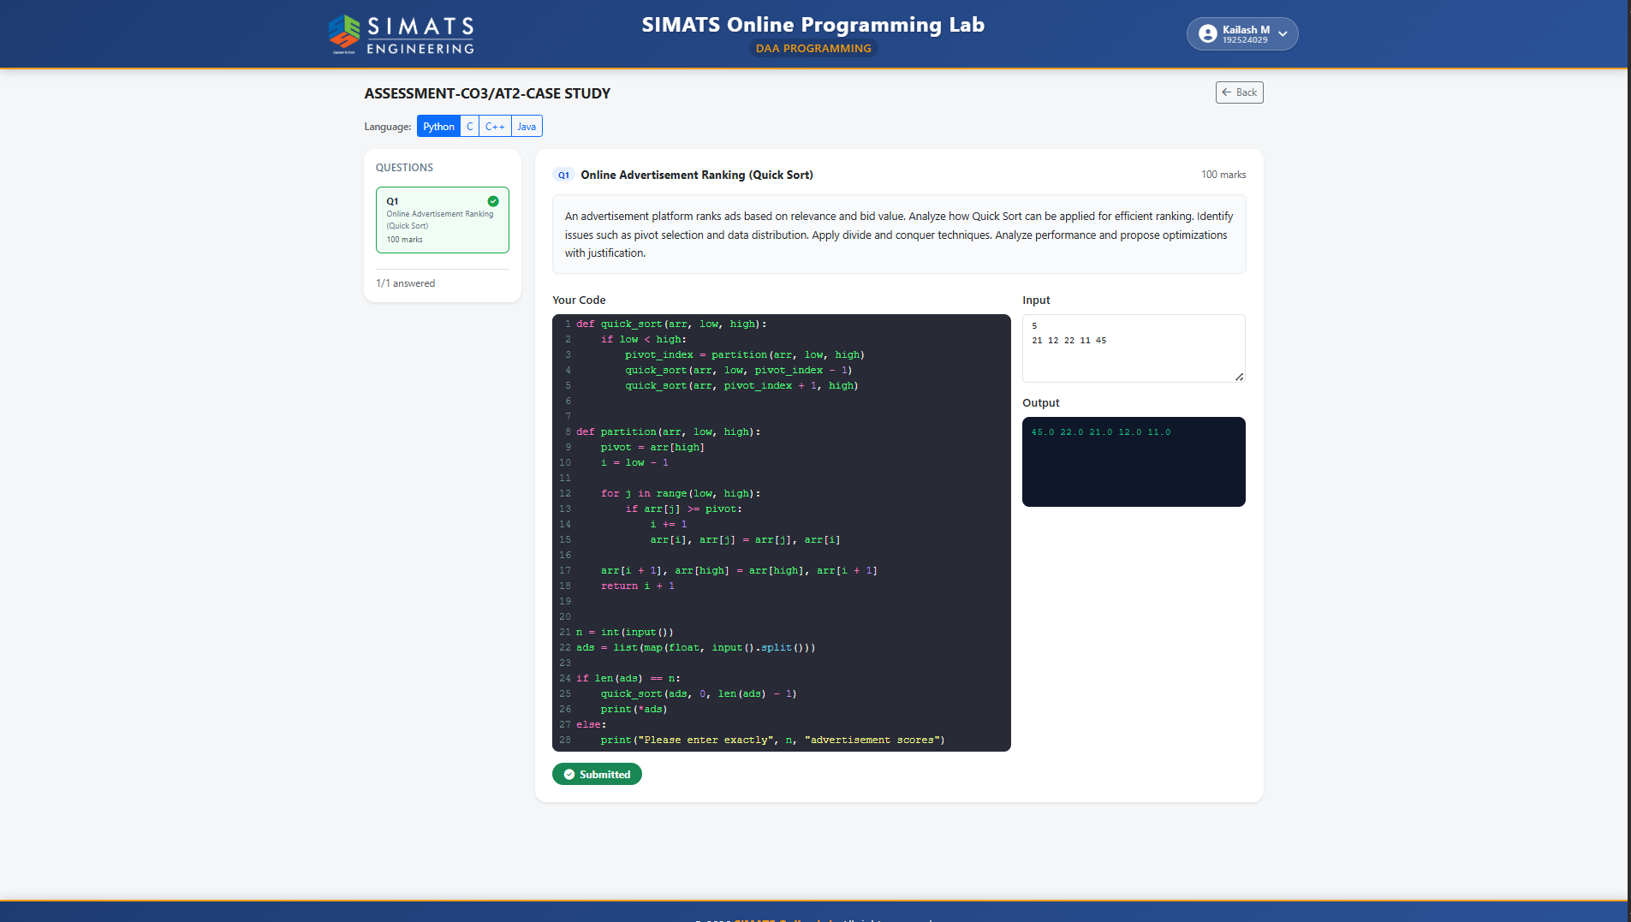

RUBRICS FOR CALCULATION
Case Study
Criteria | Weightage | Level 4 –  Exemplary | Level 3 –  Proficient | Level 2 –  Developing | Level 1 –  Beginning
Understanding of Case | 25% | Thorough  understanding; clearly  identifies all  key issues | Good  understanding with most  issues  identified | Basic  understanding; some issues  missed | Poor  understanding; problem not  identified  correctly
Application of Concepts | 25% | Effectively  applies relevant concepts to  analyze the case deeply | Applies  appropriate  concepts with minor gaps | Limited  application of concepts | Fails to apply relevant  concepts
Analysis | 20% | In-depth  analysis with  strong  reasoning and insights | Good analysis with logical  reasoning | Basic analysis with limited  depth | Weak or no  analysis; lacks reasoning
Solution  Design | 20% | Innovative,  feasible  solutions with strong  justification | Logical  solutions with adequate  justification | Basic solutions with weak  justification | Incorrect or no solution  provided
Clarity | 10% | Clear, well  structured, and easy to  understand | Organized and understandable presentation | Limited clarity and structure | Poor clarity;  difficult to  understand

Marks Evaluation:
Criteria | Wt. | Level 4 –  Exemplary | Level 3 –  Proficient | Level 2 –  Developing | Level 1 –  Beginning
Understanding of Case | 25%
Application of Concepts | 25%
Analysis | 20%
Solution Design | 20%
Clarity | 10%
Total Marks (100):

Faculty In-charge | Course Coordinator | Head of Department
Name: | Name: | Name:
Signature: _______________ | Signature: _______________ | Signature: _______________
Date: ___________________ | Date: ___________________ | Date: ___________________

